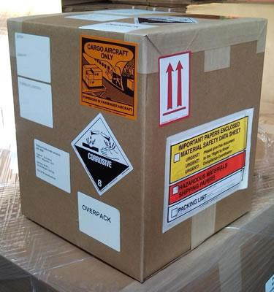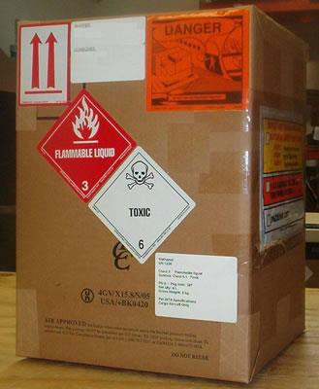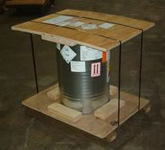

DANGEROUS GOODS
AWARENESS

Category 7, 8 &10
Revised January 2017

Rev. No | Date | Contents | Remarks
01 | 1/2017 | New book and test.
02
03
04
05
06
07
08
09
10
11
12
13
14
15
16
17
18

GENERAL PHILOSOPHY

Dangerous goods can be transported safely by air only if certain principles are strictly followed.

CLASSIFICATION – Determines the acceptability and conditions of the articles and substances for air transport and meets the criteria of one or more of the nine UN hazard classes (1-9). The shipper is responsible for determining the correct Class or Division for all dangerous goods.

FORBIDDEN DANGEROUS GOODS are identified as being too dangerous to be carried on any aircraft
under any circumstances (Totally Forbidden) and those which are forbidden under normal circumstances but may be carried with specific approvals from the States concerned (Forbidden unless exempted).

CARGO AIRCRAFT ONLY (CAO) Dangerous Goods are those items restricted to carriage on an all-cargo aircraft. Strictly forbidden on a Passenger Aircraft.

PASSENGER AND CARGO AIRCRAFT Dangerous Goods are those items that can be carried on both the passenger and cargo aircraft.

TRAINING is a mandatory requirement for all individuals involved in the preparation, handling, loading, storing and/or transport of dangerous goods by air. Depending on the job-function, this may only require familiarization training or may also include more detailed training of the Regulation.

Recurrent training must take place within 24 months of previous training to ensure knowledge is current. A test must be undertaken following the training to verify understanding of the regulations.

PACKAGING is the essential component in the safe transport of dangerous goods by air. The use of UN specification packaging and Limited Quantity packaging. The quantity of dangerous goods permitted within these packaging’s are strictly limited by the Regulations so as to minimize the risk should an incident occur.

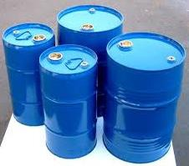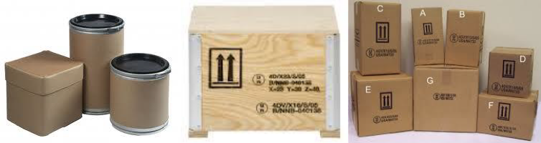EXAMPLES OF PACKAGING

Steel Drums | Fiber Drums Plywood Boxes Fiberboard Boxes Composite | Plastic
Jerri cans | Packaging

Packages are marked with required markings and bear the required labels to ensure that the hazards can be recognized without relying on accompanying documentation in an emergency.

The SHIPPERS DECLARATION FOR DANGEROUS GOODS is completed by the shipper or their agent and confirms that everyone in the transportation chain know when dangerous goods are being transported. This ensures that they are correctly accepted, handled and loaded and if an incident or accident occurs, either in-flight or on the ground, what the correct response should be.

NOTIFICATION TO PILOT IN COMMAND (NOTOC): The pilot-in-command must know what dangerous goods are on the aircraft in order to properly assess and take action for any emergency that may occur. The pilot must also convey this information if possible to air traffic services to aid in the response to any aircraft incident or accident.

HIDDEN DANGEROUS GOODS: Information regarding "Hidden Dangerous Goods" must also be conveyed to passengers and shippers to assist them in recognizing dangerous goods, which they are not permitted to carry on their person, in their baggage, or as cargo and which may not be readily recognizable as being dangerous.

ACCIDENTS AND INCIDENTS: DANGEROUS goods accidents or incidents must be reported, so that an investigation by the relevant authorities can establish the cause and corrective action can be taken. Also, if as a result of these investigations changes are required in the Regulations, appropriate regulatory action can be taken without delay.

DEFINITIONS:

APPROVAL: An authorization granted by the appropriate national authority for the transport of dangerous goods that are forbidden on a passenger or cargo aircraft.

CARGO AIRCRAFT: Any aircraft other than a passenger aircraft, which carries goods or property.

CARGO IMP CODES: (Interline Message Procedure Codes) A standard system of coding for cargo messaging.

EXCEPTION: A provision in the regulation which excludes a specific item of dangerous goods from the requirements normally applicable to that item.

EXEMPTION: Authorization, other than an approval, granted by by the appropriate national authority providing relief from the provisions of the regulation.

FLASH POINT: The minimum temperature at which the vapors are ignitable.

ID NUMBER: A temporary number assigned in the 8000 series for an article or substance which a UN Number has not been assigned.

INCOMPATIBLE DANGEROUS GOODS: Dangerous goods which if mixed, would be liable to cause a dangerous evolution of heat, gas or produce a corrosive substance.

NET QUANTITY: The weight or volume of the dangerous goods in a package. PASSENGER AIRCRAFT: An aircraft that carries any other person than a crew member. UNIT LOAD DEVICE (ULD): Any type of freight and/or Aircraft container.
UN NUMBER: A four digit number assigned to identify a substance or a group of substances.

APPLICABILITY

Dangerous Goods {Hazardous Materials (HAZMAT)}Are articles or substances which are capable of posing a risk to health, safety, property or to the environment and which are shown in the list of dangerous goods in these Regulations or which are classified according to the Regulations.

Basis of these Regulations

The UN Subcommittee of Experts on the Transport of Dangerous Goods (SCoETDG)) develops recommended procedures for the transport of all types of dangerous goods except radioactive materials.

The International Atomic Energy Agency (IAEA) develops recommended procedures for the safe transport of radioactive materials.

The International Civil Aviation Organization (IACO) has used these recommendations as the basis for developing the regulations for the safe transport of dangerous goods by air.

The International Air Transport Association (IATA) contain all requirements of the ICAO regulation and has included requirements that are more restrictive.

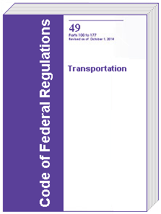DANGEROUS GOODS REGULATIONS

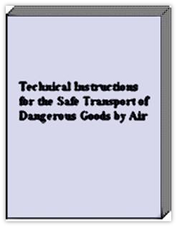CODE OF FEDERAL REGULATIONS 49 (49CFR PARTS 171-180) The United States Regulation for the transport of Dangerous Goods. The transport of dangerous goods to, from or within the United States must be in accordance with 49CFR

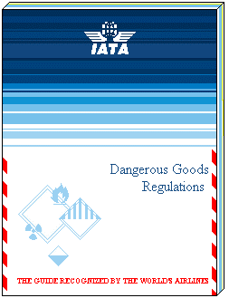ICAO TECHNICAL INSTRUCTIONS FOR THE SAFE TRANSPORT OF DANGEROUS GOODS BY AIR forms the basis for International and National laws concerning Dangerous Goods. ICAO Technical Instructions and its variations are in compliance with 49CFR.

ATA DANGEROUS GOODS REGULATION is used by the airlines as the everyday field regulation. This regulation complies fully with the ICAO Technical Instructions, and in some cases is more restrictive.

SHIPPER RESPONSIBILITIES:

The shipper is responsible for ensuring that the following items are accomplished prior to Dangerous Goods being shipped:
Identification
Classification
Packaging Marking Labelling Documentation

OPERATORS RESPONSIBILITIES:

The operator is responsible to ensure the following is accomplished: Acceptance
Storage
Loading
Inspection NOTOC Reporting
Retention of Records
Training

TRAINING: A mandatory requirement, a test must be given and recurrent training must be given every 24 months.
MINIMUM TRAINING REQUIREMENTS

Aspects of transport of dangerous goods by air  with which they should be familiar, as a minimum | Operators and Ground Handling  Agents
 | 7 | 8 | 10
General Philosophy | X | X | X
Limitations | X | X | X
General requirements for shippers
Classification |  |  | X
List of dangerous goods
General Packing Requirements
Packing Instructions
Labeling and marking | X | X | X
Shippers declaration and other relevant  documentation | X
Acceptance procedures
Recognition of undeclared dangerous goods | X | X | X
Storage and loading procedures |  | X | X
Pilot’s notification |  | X | X
Provisions for passengers and crew | X | X | X
Emergency Procedures | X | X | X

7 Operator’s and ground handling agent’s staff accepting cargo or mail (other than dangerous goods).
8. Operator’s and ground handling agent’s staff involved in the handling, storage and loading of cargo or mail and baggage.
10. Flight crew members, loadmasters, load planners and flight operations officers/flight dispatchers.

LIMITATIONS

GENERAL
Limitations are placed on dangerous goods which are permitted to be transported by air.
Aircraft limitations are:

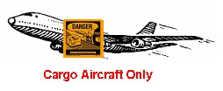FORBIDDEN dangerous goods which are too dangerous to be carried by aircraft, CARGO AIRCRAFT ONLY dangerous goods may only be carried on cargo aircraft CARGO AND PASSENGER AIRCRAFT some dangerous goods are acceptable on both.
HIDDEN DANGEROUS GOODS

Hidden or undeclared dangerous goods is cargo that is declared under a general description which may contain hazardous articles that are not apparent. It is essential that undeclared dangerous goods are not loaded onto an aircraft. Operator's acceptance staff must be trained to identify and detect dangerous goods presented as general cargo. Cargo acceptance staff should seek confirmation from shippers about the contents of their cargo where there are suspicions about the contents of their cargo. Items listed below can be suspect of having dangerous goods inside the packages.
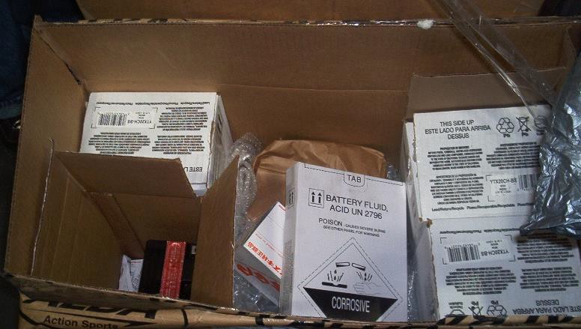HIDDEN DANGEROUS GOODS

Aircraft Parts Automobile Camping Equipment Company Material Household Goods Tool Boxes

Example Shipment: The above picture represents a shipment that was presented for shipment as general cargo. The box was opened for security reasons. Upon opening the box, batteries were found. These
were not declared upon acceptance.

TRANSPORT OF DANGEROUS GOODS BY POST

Dangerous goods, other than those listed below, are forbidden for carriage in air mail. The following items may be accepted by mail subject to the provisions of the appropriate national authorities concerned and provided that they comply with the requirements of the DGR:

• Patient specimens provided that they are classified, packed and marked as required

• Infectious substances, assigned to Category B (UN 3373) only, when packed in accordance with the requirements of Packing Instruction 650, and carbon dioxide, solid (dry ice) when used as a refrigerant for infectious substances (UN 3373); and

• Radioactive material, in an excepted package UN2910 and UN2911 only when the activity does not exceed one tenth of the Excepted Package limits

DANGEROUS GOODS IN OPERATOR’S PROPERTY
The following shipments may be shipped without being declared. Aircraft equipment
Consumer goods
Carbon Dioxide Solid (Dry Ice) used for food and beverage service
Battery powered electronic equipment
Aircraft Spares

EXCEPTED QUANTITIES REQ: Small quantities of dangerous goods.

IATA DGR Excepted Quantity Codes for Table 4.2 (Column F)

EQ Code | Maximum net quantity per  inner packaging | Maximum net quantity per  outer packaging
E0 | Not permitted as Excepted Quantity
E1 | 30g/30ml | 1 kg/1 L
E2 | 30g/30ml | 500 g / 500 ml
E3 | 30g/30ml | 300 g / 300 ml
E4 | 1g/1ml | 500 g / 500 ml
E5 | 1g/1ml | 300 g / 300 ml

Excepted Package Mark
* -- Place for Class or Division Number

** -- Place for name of shipper or consignee
If not shown elsewhere on package

Limited Quantities
Limited Quantities are only allowed in combination packaging. Single packaging and composite
packaging are not authorized. The gross weight of a Limited Quantity package must not exceed 30 kg/66 lbs.

STATE AND OPERATOR VARIATIONS
States (countries) and operators (airlines) may submit their own variations to the Dangerous Goods
Regulations.

United States Variations (USG)

These variations always have to be complied with:

USG-01- Transport of dangerous goods by air must be accordance with United States Regulations (49CFR parts 171-180) or the ICAO Technical Instructions as limited by 49 CFR part 171 Subpart C. The IATA Dangerous Goods Regulation are fully in compliance with ICAO Annex 18 and its associated Technical Instructions.

USG-12 – On shipments to, from or within the US, emergency response information must be provided.
The Shipper’s Declaration for Dangerous Goods must include an emergency telephone number.
USG-13 –
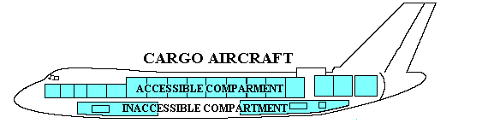
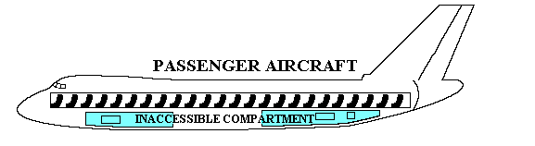

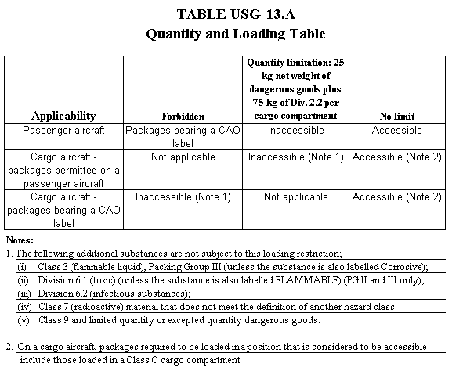
8

USG-17 Shippers and operators must comply with the security requirements as prescribed in 49CFR Part 172, subpart I, as applicable.

CLASSIFICATION
Dangerous goods are divided into 9 hazard classes reflecting the type of risk involved. Some hazard
classes are further sub-divided into divisions to identify a particular risk, within that class. Classes are expressed by single-digit numbers. For example, Class 7. 1, 2, 3, 4, 5, 6, 7, 8, 9
Divisions are expressed by 2-digit numbers. 1.1 – 1.6, 2.1 – 2.3, 4.1 – 4.3, 5.1, 5.2, 6.1, 6.2
The first digit identifies the Class number and the second identifies the division within that class.

Three letter Cargo-IMP (Interline Message Procedures) Codes are assigned to each class/division to facilitate recognition of the presence of dangerous goods on various flight documents, such as cargo manifests and Special Load - Notification to Captain (NOTOC).

Hazard Classes and Divisions are shown below:
CLASS 1 – EXPLOSIVES - materials or items which have the ability to rapidly conflagrate or detonate as a consequence of chemical reaction. Has 6 Sub-Divisions

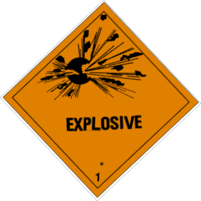CLASS/DIVISION IMP CODE DESCRIPTION LABEL

DIVISION - 1.1 | REX, RCX, and RGX | having a mass explosion hazard
DIVISION - 1.2 | REX, RCX, and RGX | having a projection hazard but not a mass explosion hazard,
DIVISION - 1.3 | REX, RCX, and RGX | having a fire hazard, a minor blast hazard  and/or a minor projection hazard but not a mass explosion hazard

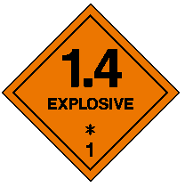

DIVISION - 1.4 RXB, RXC, RXD, Presents no significant hazard
RXE, RXG, and
RXS

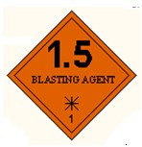

DIVISION - 1.5 REX Very insensitive substances having a explosion hazard

9

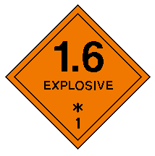DIVISION - 1.6 REX Extremely sensitive articles which do not
Have a mass explosion hazard

NOTE:

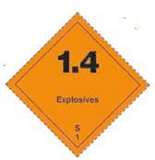1. Explosives in Divisions 1.1, 1.2, 1.3, 1.4F, 1.5 and 1.6 normally forbidden for air carriage.

2. Explosives in Division 1.4S (RXS) only explosive allowed on passenger aircraft.

CLASS 2 – FLAMMABLE GAS, NON FLAMMABLE GAS AND TOXIC (POISON) GAS has 3 Sub-Divisions

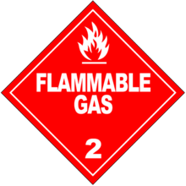DIVISION - 2.1 (RFG) FLAMMABLE GAS

Any gas when mixed with air in certain proportions, forma a flammable mixture

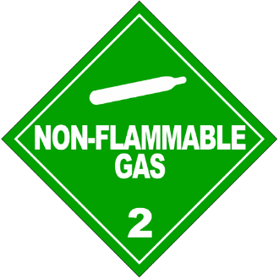DIVISION – 2.2 (RNG) NON FLAMMABLE GAS

Any non-flammable, non-toxic gas or low-temperature liquefied gas.

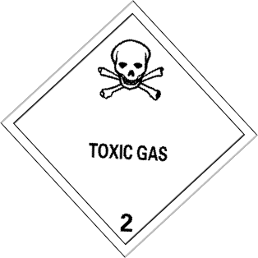DIVISION - 2.3 (RPG) TOXIC (POISON) GAS

Known to be so toxic or corrosive to humans as to pose a health risk

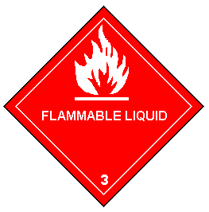CLASS 3 – (RFL ) FLAMMABLE LIQUIDS

a

Liquids, mixtures of liquids or liquids containing solids in solution which give off
Flammable vapor (have a flash point) at temperatures of not more than 60°C

CLASS 4 – FLAMMABLE SOLIDS, SPONTANEOUSLY COMBUSTIBLE AND DANGEROUS WHEN WET

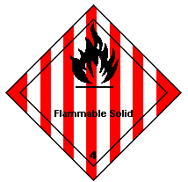DIVISION - 4.1 (RFS) FLAMMABLE SOLIDS -

r may

Materials which, under conditions encountered in transport, are readily combustible o
Cause or contribute to fire through friction

DIVISION - 4.2 (RSC) SPONTANEOUSLY -

or
COMBUSTIBLE

Substances which are liable to SPONTANEOUS heating under normal transport conditions, To heating up in contact with air, and are consequently liable to catch fire.

DIVISION - 4.3 (RFW) DANGEROUS WHEN WET

Substances which emit flammable gases or. Become spontaneously flammable when in contact with water

CLASS 5 – OXIDIZERS AND ORGANIC PEROXIDES have 2 Sub-Divisions

DIVISION - 5.1 (ROX) OXIDIZERS–

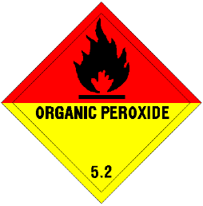
Substances which may cause or contribute to combustion, generally by yielding oxygen as a result of a chemical reaction

DIVISION - 5.2 (ROP) ORGANIC PEROXIDES –

Substances which may be considered derivatives of hydrogen peroxide

CLASS 6 – TOXIC (POISON) SUBSTANCES AND INFECTIOUS SUBSTANCES have 2 Sub-Divisions
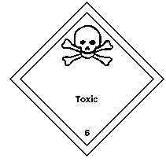DIVISION – 6.1 (RPB) TOXIC (POISON) SUBSTANCES - Substances that are liable either to cause death or serious injury or to harm human
health if swallowed, inhaled or by skin contact.

DIVISION - 6.2 (RIS) INFECTIOUS SUBSTANCES

s, imals.
Substances which are known or can be reasonably expected to contain bacteria, viruse
rickettsia, parasites and fungi, or other agents which can cause disease in humans or an

NOTE:

UN3373 (RDS ) BIOLOGICAL SUBSTANCE, CATEGORY B

Must comply with Packing Instruction 650 in the IATA Dangerous Goods Regulation. Must be marked with the Biological Substance Mark

CLASS 7 – RADIOACTIVE MATERIALS HAVE 3 categories No Sub Divisions

Category 1 (RRW) Radioactive White I T.I. = 0 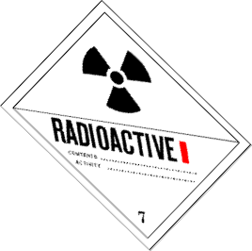

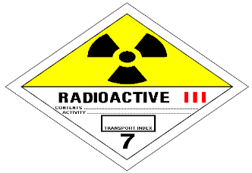Category II (RRY) Radioactive Yellow II T.I. > 0 < 1 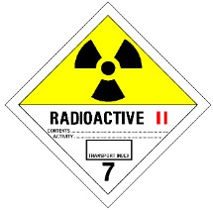

Category III (RRY) Radioactive Yellow III T.I. > 1 < 10

TRANSPORT INDEX (T.I.) – is a number assigned to a package, overpack or freight container used to provide control; over radiation exposure. The T.I. is determined by a measurement of radiation level at a distance of 1m from the external surface of the package, overpack or freight container.. The T.I. determines the category and label for the radioactive material.

CLASS 8 – (RCM) CORROSIVE MATERIAL

Substances which by chemical action degrade or disintegrate other materials upon contact.

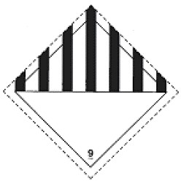CLASS 9 – (RMD) MISCELLANEOUS MATERIAL

Substances and articles which during transport present a danger or hazard not covered by other classes.

Examples of Class 9

Carbon Dioxide Solid (Dry Ice) ICE Lithium ION Batteries RLI Lithium Metal Batteries RLM
MAGNETIZED MATERIAL MAG

PACKING GROUPS
There are three packing groups (I, II, III) relating to the degree of danger within the hazard class. Packing Group I – Highest Risk
Packing Group II – Medium Risk
Packing Group III – Low Risk

Packing groups do not apply to Classes 1, 2 or 7.

IDENTIFICATION

SELECTING THE PROPER SHIPPING NAME
The proper shipping name is used to identify the article or substance on the outside of the package and on the
shipper’s declaration for dangerous goods.

These are examples of how the entries in the list of dangerous goods are listed. There are four types listed below. Single entries for well-defined substances or articles:

EX. – Kerosene UN1223
Generic entries for a well-defined group of articles or substances

EX. – Adhesives UN1133

Specific n.o.s. entries covering a group of substances or articles of a particular chemical or technical nature.

EX. – Refrigerant gas n.o.s. UN1078

General n.o.s. entries covering a group of substances or articles meeting the criteria of one or more classes or divisions.

EX. – Corrosive Solid n.o.s. UN1759

List of Dangerous Goods

This list is listed by proper shipping name in alphabetical order and has 14 Columns A-N listed below.

UN/ ID No. A | Proper Shipping Name  B | Class  or Div. (Sub Risk) C | Hazard Label(s) D | PG E | Passenger and  Cargo Aircraft |  |  |  |  | Cargo  Aircraft Only |  | S/P M | ERG Code N
 |  |  |  |  | EQ F | Pkg Inst G | Max.Net Qty/Pkg H | Pkg Inst I | Max.Net Qty/Pkg J | Pkg Inst K | Max.Net Qty/Pkg L

Numerical List

This is a cross reference to the list of Dangerous Goods. Listed by the UN Number in numerical order and references Name and Description and Page No.

Special Provisions

PACKING
The shipper is responsible for the packing of dangerous goods.

METHODS OF PACKING

COMBINATION PACKAGINGS - consist of an outer packaging manufactured from wood, fiberboard, plastic or metal and contain inner packagings of metal, plastic, glass etc., and may be packed
in absorbent or cushioning material.
COMBINATION PACKAGING

SINGLE PACKAGINGS - require no outer packaging for protection and are manufactured from steel, aluminum, plastic or other permitted materials.
Single Packaging

OVERPACK - is an enclosure used by a single shipper to contain one or more packages to form one handling unit for convenience of handling and stowage.

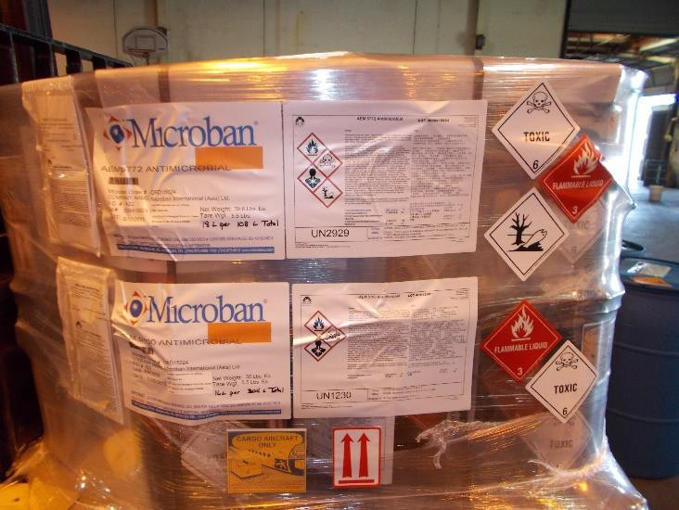Note: An aircraft Unit Load Device (ULD) is not considered as an overpack.

Examples of overpacks are:

A strong outside fiberboard box or drum, A wooden box or barrel
A metal barrel or drum. A wooden crate
Packages strapped to a warehouse skid/pallet.

Note: Shrink wrapping or strapping may be used as overpacks.

TYPES OF PACKAGING LIMITED QUANTITY PACKAGING
Limited Quantity packaging provisions recognize that many dangerous goods in small quantities present a reduced hazard, and can be safely transported in good quality combination packagings. Limited quantity packaging cannot exceed 30 kg/66lbs gross weight. Such packagings must bear the Limited Quantity marking. Note: Limited Quantity Packagings do not require UN specification markings.

Limited Quantity for Limited Quantity mark
Air Transport for road, rail and sea transport.

Either marking is acceptable
UN SPECIFICATION PACKAGING are subject to performance tests designed to ensure that the packages tested will not lose any of their contents under normal transport conditions. The letters X, Y and Z indicate the design type of package to which it was successfully tested.
UN specification marking
X – Packing Group I
Y – Packing Group II 4G/X50/17/USA/+AB246
Z – Packing Group III MARKING AND LABELLING GENERAL
Marking and labelling is the responsibility of the shipper to ensure that correct marks and labels are correctly applied to the packages..

Acceptance staff is required to check and make sure that all packages are correctly marked and labeled before accepting the consignment.

Two types of marking

Package Specification Marking -Un Specification code identifying the package.

Package Identity marking

Proper Shipping Name
UN Number
Shipper and consignee

Labelling
The shipper is responsible for labeling a package or overpack containing dangerous goods.

The operator or airline is responsible only for replacing labels that become detached or unidentifiable during transport.

Packages containing dangerous goods must be properly labeled to indicate their contents.

There are two types of labels (Hazard and Handling Labels)

HAZARD LABELS must be displayed on the outside of each package. Hazard labels may have text describing the nature of the hazard, but this is not mandatory on most hazard labels. Must have the Class or Division Number on the label.
HANDLING LABELS - Certain dangerous goods require special handling labels, which may be in addition to, or in some cases, instead of the hazard label, because they need to be handled or loaded in a particular manner.

Handling labels are listed below.

Cryogenic Liquid (RCL) - used on packages containing refrigerated liquid gases, or
Cryogenic Liquids.
This label is used with the 2.2 Non-Flammable Label.

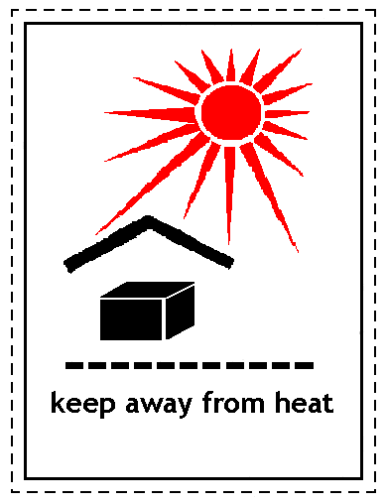Keep Away from Heat –These shipments must be protected from direct sunlight all sources of heat and be placed in adequately ventilated areas.
and

This label is used for the following shipments: DIVISION 4.1 SELF-REACTIVE SUBSTANCES DIVISION 5.2 ORGANIC PEROXIDES

Excepted Packages of Radioactive Material (RRE) -

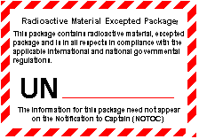

Must be affixed to all excepted packages of radioactive material.

Magnetic Material (MAG): (Class 9)
The Class 9 hazard label is not required. Magnetized Material must be loaded away from the aircraft compass
detector unit.
.
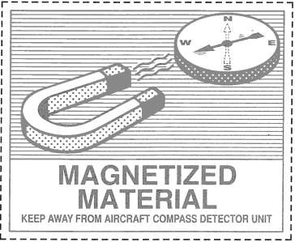

CARGO AIRCRAFT ONLY (CAO)

A package that has the Cargo Aircraft Only label is forbidden on a passenger aircraft.

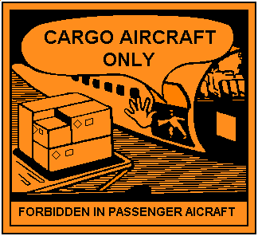

ORIENTATION LABELS:

Orientation labels are required on combination packaging and overpacks containing liquids. Two orientation labels must be affixed on two opposite sides of the package.

LITHIUM BATTERIES (ELI / ELM) - Must be affixed to packages of lithium batteries when required by Section II of the applicable packing instruction.
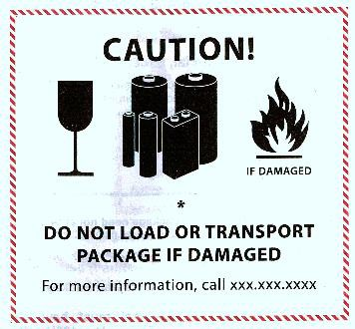

ENVIRONMENTALLY HAZARDOUS SUBSTANCE MARK.

MARKING AND LABELLING

Mandatory Marks and Labels Marks and labels are only required when needed

Proper Shipping Name Cargo Aircraft Only Label
UN/ID Number Orientation Labels Hazard Labels UN Specification Code Name and address of Shipper and Consignee

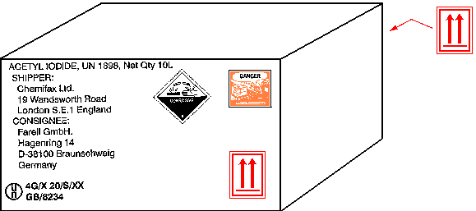

DOCUMENTATION

The SHIPPERS DECLARATION FOR DANGEROUS GOODS is required for Dangerous Goods Shipments. This is prepared by the shipper and accompanies the shipment throughout the transportation system, from shipper to consignee.
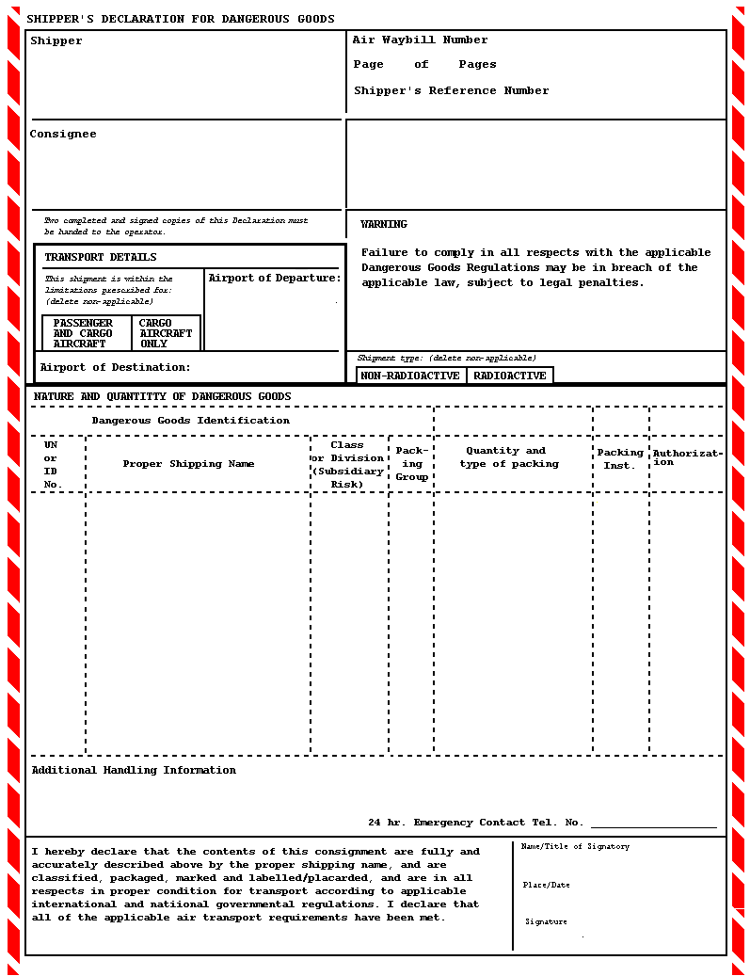
SHIPPER’S DECLARATION FOR DANGEROUS GOODS (DGD)

19

Acceptance Procedures

Incompatible Dangerous Goods – must be separated during storage and loading according to IATA Dangerous
Goods Regulation Table 9.3.A below..

Storage and Loading

TABLE 9.3.A
Segregation of Packages
Hazard Label | 1 excl. 1.4S | 2 | 3 | 4.2 | 4.3 | 5.1 | 5.2 | 8
1 excluding 1.4S | See 9.3.2.2.5 | X | X | X | X | X | X | X
2 | X | - | - | - | - | - | - | -
3 | X | - | - | - | - | X | - | -
4.2 | X | - | - | - | - | X | - | -
4.3 | X | - | - | - | - | - | - | X
5.1 | X | - | X | X | - | - | - | -
5.2 | X | - | - | - | - | - | - | -
8 | X | - | - | - | X | - | - | -

NOTE:

1. An “X” at the intersection of a row or a column indicates that the packages containing these classes/divisions of dangerous goods must be segregated. A “” at the intersection of a row and a column indicates that packages containing these classes/divisions of dangerous goods do not require segregation.

2. Divisions 1.4S, 4.1 and classes 6, 7, and 9 are not included in table 9.3.A as they do not require segregation from other classes of dangerous goods.

STORAGE, LOADING AND HANDLING

The following aspects must be addressed to ensure proper storage and handling of packages containing dangerous goods inside the warehouse and when being loaded on, or unloaded from, an aircraft:

Dangerous Goods must be:

Inspected prior to acceptance, storage, loading and handling to ensure the packages/overpacks are free from damage and leaks.

Protected from Damage

Dangerous goods must be protected from accidental damage during their preparation, handling, storage, loading and unloading. Must be secured to prevent any movement under conditions normal to air transport. Dangerous goods must be secured in all directions: up/down; forward/aft; left/right to prevent movement.

Handling

When transporting dangerous goods by forklift always travel in reverse. When storing in the dangerous goods storage area ensure the shipment is placed on an additional skid (pallet).

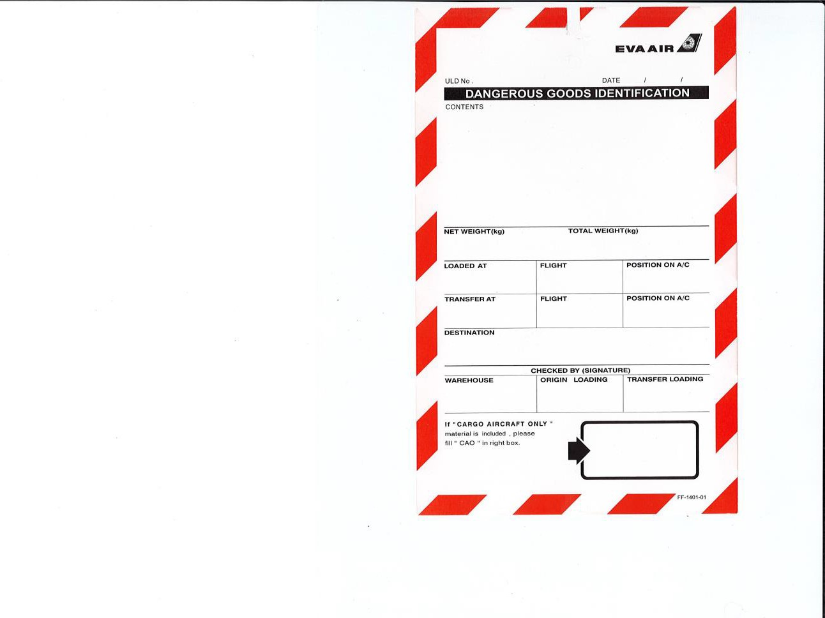Storage and Loading

Packages bearing the package orientation label must be loaded, stowed and handled at all times in accordance with such a label. Single packaging’s with end closures containing liquids must be stowed with such closures upwards.

LOADING OF LIVE ANIMALS WITH DANGEROUS GOODS

Do not load live animals (AVI) with
Cryogenic liquids, Dry ice.
Toxic Substances Division 6.1
Infectious Substances Division 6.2
Category II-Yellow and III-Yellow radioactive materials .

UNIT LOAD DEVICES (ULD) CONTAINING DANGEROUS GOODS

Each ULD containing dangerous goods, must clearly display on its exterior a Dangerous Goods Pallet Tag on two sides showing that dangerous goods are contained within the ULD. The primary and subsidiary hazard c1ass(s) or division(s) numbers of the dangerous goods must be clearly marked on the tag.

If the ULD contains packages bearing the "Cargo Aircraft Only" label, the tag must indicate that the
ULD can only be loaded on a cargo aircraft.

PROVISION OF INFORMATION

PILOT-IN-COMMAND - NOTIFICATION TO CAPTAIN (NOTOC)
The pilot-in-command of an aircraft in which dangerous goods are to be carried must be provided as soon as practicable prior to departure of the aircraft, with accurate and legible written or printed information concerning
dangerous goods to be carried as cargo.

This information should be presented on a dedicated form and not by means of "Air Waybills", "Shipper's Declaration for Dangerous Goods", etc. Generally this information is presented on a "Special Load - Notification to Captain (NOTOC)" form.

Notification to Captain (NOTOC) Sample

The NOTOC is not required for Dangerous Goods in Excepted Quantities or for Excepted Packages of
Radioactive Material.

The NOTOC must include, as a minimum, the following:

Note: This includes information about dangerous goods loaded at a previous departure point and which are to be carried on the subsequent flight.

• Air Waybill number
•Proper shipping name supplemented with the technical name (s) if appropriate
The NOTOC must be readily available to the pilot-in-command during flight.

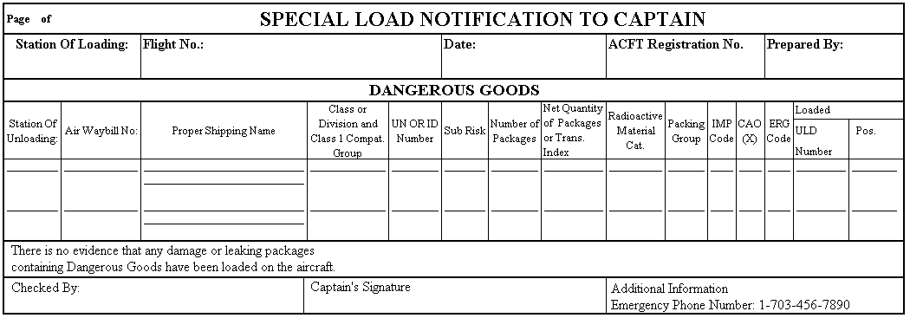

The pilot-in-command taking over a transit aircraft, must be notified of all transiting dangerous goods still on the aircraft..
DANGEROUS GOODS EMERGENCY RESPONSE

The following basic procedures are given as an example. It is important that you are familiar with your local requirements and are aware of all emergency contacts.

GENERAL PROCEDURES FOR RAMP AND WAREHOUSE PERSONNEL
General emergency procedures to be followed comprise of the following in the event of a spill or leakage
involving dangerous goods is as follows:

• Notify immediate supervisor first;
• Identify the dangerous goods (if safe to do so);
• Where safe to do so, isolate the package by removing other packages or property;
• Avoid contact with the contents of the package;
• If the contents come in contact with your body or clothes:
• thoroughly wash off body with plenty of water,
• remove contaminated clothing,
• do not eat or smoke,
• keep hands away from eyes, mouth and nose,
• seek medical assistance;
• Staff involved in such incidents should stay on site until their names are noted.

INCIDENTS AND ACCIDENTS

Dangerous Goods Accident: Is an occurrence related to the transport of dangerous goods by air that
results in fatal or serious injury to a person or serious damage to property.

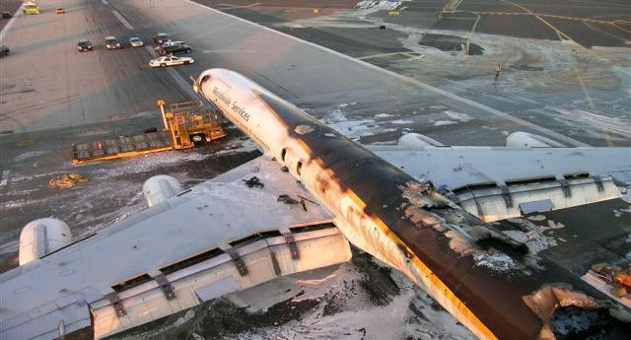

DANGEROUS GOODS INCIDENT: An occurrence, other than a dangerous goods accident, related to the transport of dangerous goods by air, which results in injury to a person, property damage, fire breakage, spillage, leakage of fluid or radiation, or other evidence that the integrity of the packaging has not been maintained. Any occurrence relating to the transport of dangerous goods by air which seriously jeopardizes an aircraft or its occupants is also a dangerous goods incident.

